FOR SALE VILLA
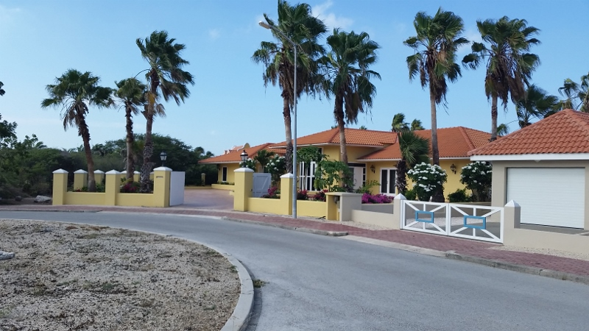
Villa 5 at Coral Estate

- Size: m2  - Living space: 700 m2  - Large terrace with Kazebo  - Swimming pool  - 1 master bedroom + Walk-in closet + bathroom  - 4 bedrooms  - 3 bathroom  - Spacious kitchen  - Laundry  - Stairway to ocean |  | This villa is situated at the prestigious gated resort of Coral Estate.  The entrance of the premises is through a driveway that is bordered by the natural vegetation of Curacao with an independent guest quarters located on each side.  This classic Curacao Style oceanfront villa is located on the best spot on Coral Estate. Quiet, on the eastside a green buffer for maximum privacy. Meters above the Caribbean Sea. Just 2 minutes from the beach and restaurants  Price: US$ 1,200,000.- Buyers Cost incl furniture
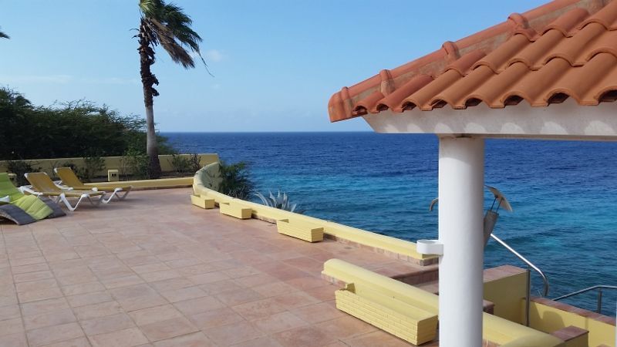 | 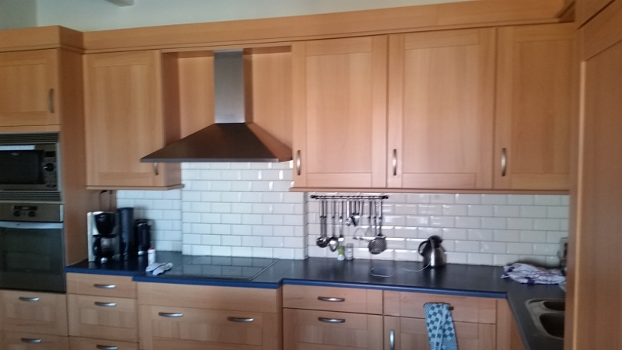 |  | 